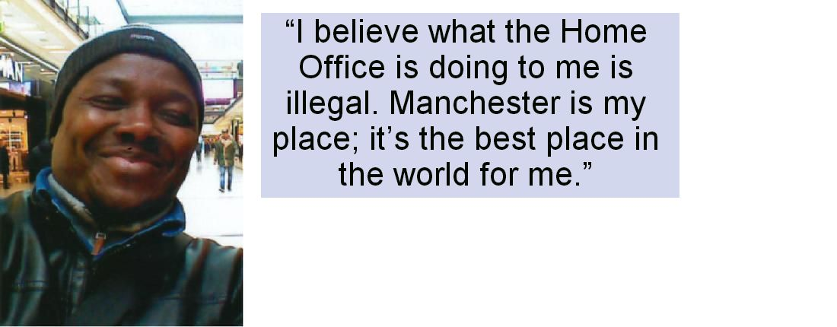

UPDATES & HOW TO HELP
Nestor must be released immediately | Please circulate this document far and wide. Sign the 38 degrees petition below and encourage your networks to sign and share

Why is this important?
Nestor was detained on Friday 30th June 2017. He had a new Leave to Remain application that was received by the Home Office before he was detained, therefore his detention was unlawful. His lawyer, Mervyn Cross of Duncan Lewis says:”There is absolutely no reason to detain Nestor.”

A natural helper, a vital carer for both Lawrence, aged 14, and for Elizabeth Coleman, retired, Lawrence says: “He’s a really great guy and helps me with my homework and takes me to school.” And Elizabeth says: “Nestor’s home is England. He is like a son to
me. He has a lot to contribute to our society.”

Nestor himself says: “I believe what the Home Office is doing to me is illegal. Manchester is my place; it’s the best place in the world for me.”
See http://www.rapar.org.uk for full RAPAR campaign details.

This man and his new family need and want to be together. We are therefore asking people to sign this petition, urging the Home Office to immediately release him from this unlawful detention.

How it will be delivered
Electronic and hard copy to the Home Office.

Full Name | Postcode | Email | Signature

