RAPAR
Manchester-based Human Rights organisation
HUNGER STRIKER NOW HANDCUFFED
TO HILLINGDON HOSPITAL BED
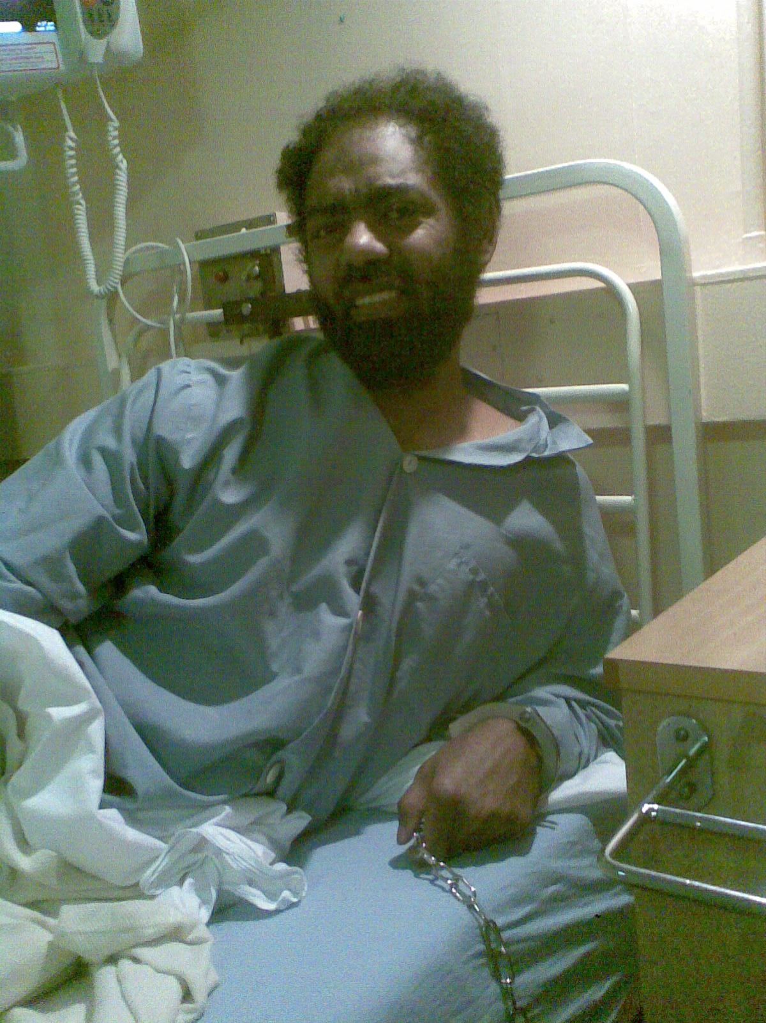
- After 36 days’ hunger strike, Mortada, of Eastern Sudan, removed to hospital and handcuffed to his bed
- Mortada is not a criminal and should be treated with respect
- Friday 23rd December, 2pm, Solidarity and Protest vigil outside Immigration Appeals Tribunal Court, Mount Street, Manchester

The dehumanising treatment and continuing threat of removal facing Mortada, aged 36, from Eastern Sudan is being highlighted by the Beja Congress, the opposition party of East Sudan, alongside RAPAR tomorrow.

.
Mortada Mohamed Ahmed, from Eastern Sudan, who had not eaten from 9th November until last Friday was taken to Hillingdon Hospital and then handcuffed to his bed.
Isaac Shaffer from Wilson Solicitors LLP, his lawyer said "Our client was transferred from Immigration detention and has been receiving emergency medical treatment in hospital for several days now. His admission was preceded by a hunger strike of over 30 days - a protest against his treatment by the Home Office, and in particular against his prolonged immigration detention.
However, despite being hospitalized due to his fragile medical condition (and the acute concern of independent medical experts - who also note their finding that he is a victim of torture), we have now been informed that he is currently being restrained to his hospital bed via metal handcuffs. We strongly consider that there is nothing to indicate that this continued and egregious infringement upon our client’s fundamental right to liberty is appropriate." .
Having already won an injunction preventing removal, the legal process to ensure he can stay in the UK continues. His lawyer stated: "We remain deeply concerned about the health and well-being of our client. We strongly hope that now, following the High Court's grant of an injunction against removal, the Home Office will urgently reconsider whether his continued and prolonged detention remains lawful and indeed reasonable in the circumstances."
Abu Amna, a member of the Beja Congress and friend of Mortada said, “I think it is very inhumane to treat a patient like that. So long he is in hospital, he is a patient, he should be treated like other patients. He is in the care of the medical staff and I wonder why they tolerate such practices. Since the UKBA policy says "Restraints must not be used to attach detainees to furniture or any other fixtures and fittings”, something must have gone terribly wrong. He is a patient and must not be treated like this in the hospital.”
RAPAR spokesperson Nahella Ashraf said “We call up on anyone who can to take a few minutes out of their preparations for the Christmas holiday to stand with us in defence of Mortada beside the Mount Street tram stop in City Centre Manchester at 2pm tomorrow, Friday. The cuffs must come off immediately.”
BACKGROUND NOTES
Mortada Mohamed Ahmed did not eat for 36 days – 9th November to 15th December. Mortada, aged 36, was in the medical wing at Colnbrook Detention Centre beside Heathrow. He had been issued with removal directions by the UKBA for Friday 16th December at 09:30 on Gulf Air via Bahrain to Sudan. However, it is unlawful to make a person board a flight where they are so ill or physically fragile that it could endanger their health further. Independent Medical experts had medically assessed him and voiced their strong concerns that he was unfit to fly.
Mortada, who, prior to being detained, was living in Leeds, has explained that he would rather die here in the safety of the UK than be returned to the Sudan from which he fled in 2005 during the Port Sudan Massacre. He began his hunger strike after he was detained and told by the Home Office that he was going to be sent back to Sudan. “I started the hunger strike because I do not have any choice” he says. Mortada’s one remaining brother and sister are in Saudi Arabia; the rest of his family died in the Sudan.
James Fallah-Williams from RAPAR, who was himself on hunger strike for 19 days earlier this year says: “When I spoke Mortada’s lawyer (13/12/11) he told me he was ‘on the case’. I have just spoken with Mortada today and he sounds very weak.”
A spokesperson for Medical Justice who had seen Mortada in Colnbrook said: “An independent doctor who visited him and has been monitoring him since has assessed him as not fit to fly, or to be detained, and he should be taken to hospital for further assessment.”
The flight was stopped through an intervention of the High Court, and Dr Abuamna, a leading member of the Eastern Sudanese diaspora who is based in Manchester, explained: “It would be unsafe for Mortada to go back to the Sudan now because there are so many human rights violations in Eastern Sudan. The government has been targeting and detaining activists from the Beja Congress, including ex-fighters from the Eastern Sudan.”
For further information see: http://www.sudaneseonline.com/english/ and www.rapar.org.uk
Contact:
Nahella Ashraf, RAPAR, on 07988572976
Mohammed Alhalennsy of the Beja Congress, on 07400973235
Dr Rhetta Moran, RAPAR, on 07776264646

